**What efforts were made by Nelson Mandela as well as organizations in and outside of South Africa to end apartheid?**

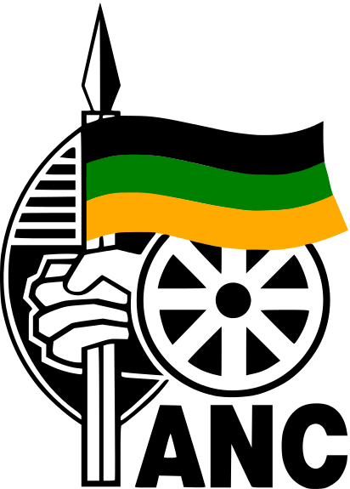

**What is the ANC?**

On January 8th 1912, chiefs, representatives of people`s and church organizations, and other prominent individuals gathered in Bloemfontein and formed the African National Congress. The ANC declared its aim to bring all Africans together as one people to defend their rights and freedoms. The ANC was formed at a time when South Africa was changing very fast. Diamonds had been discovered in 1867 and gold in 1886. Mine bosses wanted large numbers of people to work for them in the mines. Laws and taxes were designed to force people to leave their land. The most severe law was the 1913 Land Act, which prevented Africans from buying, renting or using land, except in the reserves. Many communities or families immediately lost their land because of the Land Act. For millions of other black people it became very difficult to live off the land. The Land Act caused overcrowding, land hunger, poverty and starvation.

Source: <http://www.anc.org.za/show.php?id=206>

**1. Why was the ANC created?**

**The ANC was created to end apartheid and wanted to defend African rights.**

**1984 Desmond Tutu wins the Nobel Peace Prize**

The Anglican bishop Desmond Tutu was honored with the Peace Prize for his opposition to South Africa's brutal apartheid regime. Tutu was saluted by the Nobel Committee for his clear views and his fearless stance, characteristics which had made him a unifying symbol for all African freedom fighters. Attention was once again directed at the nonviolent path to liberation.

The Peace Prize award made a big difference to Tutu's international standing, and was a helpful contribution to the struggle against apartheid. The broad media coverage made him a living symbol in the struggle for liberation, someone who articulated the suffering and expectations of South Africa's oppressed masses. There are many indications that Tutu's Peace Prize helped to pave the way for a policy of stricter sanctions (or economic penalties) against South Africa in the 1980s.

Source: http://www.nobelprize.org/nobel_prizes/peace/laureates/1984/tutu-facts.html

**2. Why did Desmond Tutu receive the Nobel Peace Prize?**

Desmond Tutu receives the Noble Peace Price for his opposition to South Africa’s apartheid regime.

**3. What did this prize reveal about recognized ways to end apartheid in South Africa?**

His prize helped to open the path to policies to end the apartheid in South Africa, and have media coverage on the apartheid.

**1986 United States Calls for Sanctions in South Africa**

In 1986, the United States passed the Comprehensive Anti-Apartheid Act. The Comprehensive Anti-Apartheid Act was a law enacted by the United States Congress which imposed sanctions against South Africa until it ended the system of apartheid. The United States issued economic, political and social sanctions that impacted the economy in South Africa.

**4. Why do you think the United States passed the Comprehensive Anti-Apartheid Act?** I believe the United States passed the Comprehensive Anti-Apartheid Act to regulate the South Africans and to help stop the apartheid system. This act would affect everybody in South Africa and would be a step towards ending the system of apartheid.

**5. How do you think the South African government felt about these sanctions?** The South African government probably felt angry about these sanctions since it impacted their economy drastically.

**1986 International Divestments and Boycotts**

In November 1962, the United Nations General Assembly passed a non-binding resolution establishing the **United Nations Special Committee against Apartheid**. This committee called for economic and other sanctions on South Africa; however, all Western nations refused to join the committee. Despite this failure, the anti-apartheid movement continued within individual countries like Britain. Boycotts and divestment took the form of refusing to buy South African goods, refusing to support South African professors, and refusing to make business investments in South Africa until apartheid ended. Additionally, South Africa did not compete at Olympic Games from 1964 to 1988, as a part of the sporting boycott of South Africa during the Apartheid era.

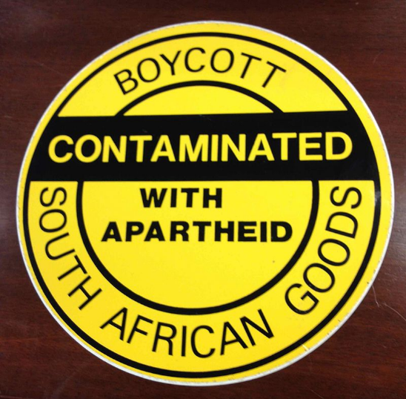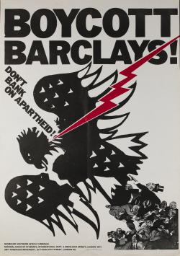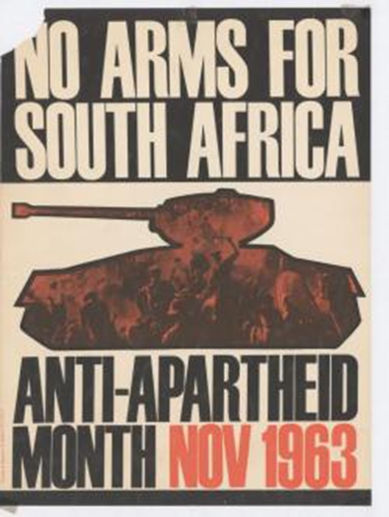

Boycott - Contaminated with apartheid - South African goods - 12 inch sticker used by activists, from the collection of the Library of Congress

by National Union of Students ,Anti-Apartheid Movement London, United Kingdom Exact year unknown, 1970s

by Anti-Apartheid Movement London, United Kingdom Undated, about October or November 1963

**6. The divestment and boycott campaigns are often credited for helping to bring apartheid to an end. How might the divestment and boycott campaigns have help dismantle apartheid?** The divestments built up pressure to stop the apartheid system since the governments needs funding to operate. Pressure to divest from campaigns around the nation would help advocate for equality in South America. Boycotts helped bring apartheid to an end since it pressured the government to change.

**7.. Why might other nations and international organizations get involved with the struggle to end apartheid?**

|  |  |
| --- | --- |
| **1989**  ***Apartheid Laws Relaxed and Mandela meets with New President*** | |
| In August 1989, F.W. de Klerk replaced P.W. Botha as state president. F.W. de Klerk made some promises to end white domination in South Africa and relaxed some of the apartheid laws. Also in 1989, de Klerk released eight of the country’s most prominent anti-apartheid political prisoners. | **8. What promises did de Klerk make when he became president in 1989?**  The promises that de Klerk made when he became the president in 1989 was to end white domination in South Africa and ease some of the apartheid laws.  **9. How might supporters of apartheid feel about de Klerk’s promises?**  Supporters of apartheid wouldn’t like de Klerk’s promises because he isn’t making a promise that benefits them.  **10. How might anti-apartheid activists feel about de Klerk’s promises?**  Anti-apartheid activists would feel relieved when they hear about de Klerk’s promises since he is making a promise that the anti-apartheid activists are trying to achieve and there would be a powerful person that is on their side.  **11. Why did de Klerk release eight anti-apartheid political prisoners?**  F.W. de Klerk released eight anti-apartheid political prisoners to give them a voice. A chance to be heard and express their opinions to help end the apartheid system. |

|  |
| --- |
| **February 11, 1990** *ANC Ban is lifted and Mandela is Released!* |
| |  |  |  |  | | --- | --- | --- | --- | | [Image](http://graphics8.nytimes.com/images/2013/06/27/world/africa/mandela-timeline-1990/mandela-timeline-1990-articleLarge.png) is courtesy of The New York Times  **12. Why was the release of Mandela an important turning point in the anti-apartheid struggle?**  The release of Mandela was an important turning point in the anti-apartheid struggle because it shows the how far they’ve come and the progression towards ending apartheid.  **13. Does the release of Mandela mean that the struggle against apartheid is over? Explain.**  The release of Mandela does not mean the struggle against apartheid is over, but it does mean that they are close to ending the struggle. More policies have to be made in order for the struggle to end. | On February 2, 1990, de Klerk lifted the ban on the ANC and other political organizations. He also promised that Mandela would be freed shortly. de Klerk also removed the restrictions placed on Black communities since the state of emergency declared by Botha in 1986.  On February 11, 1990, Mandela is finally freed at the age of 71 after being imprisoned for 27 years. After Mandela’s release, he pledged to continue his fight against apartheid and white domination.   |  |  | | --- | --- | |  | Watch the [**CNN Video of Nelson Mandela’s Release from Prison**](https://www.youtube.com/watch?v=pdRy5swdH8s) |     [Image](http://graphics8.nytimes.com/images/2013/06/27/world/africa/mandela-timeline-1990/mandela-timeline-1990-articleLarge.png) is courtesy of NPR | |
| **December 20, 1991** *Deliberations for New Constitution* | |
| In 1991, de Klerk repealed many of the remaining apartheid laws. Mandela and de Klerk sat down to begin negotiations on a new constitution. These meetings are not easy as both men disagreed on several issues. Despite these disagreements, deliberations continued. | |

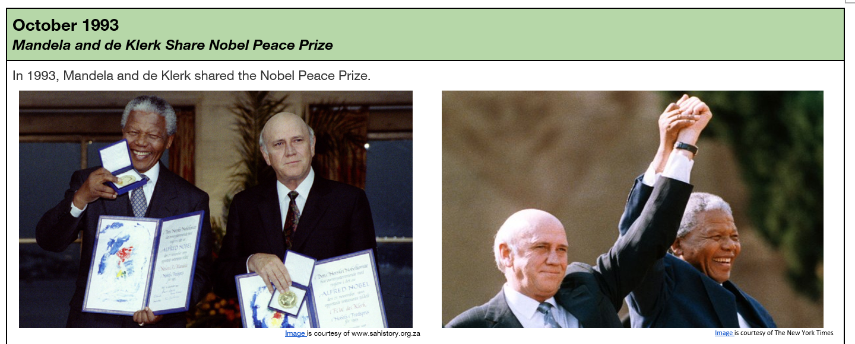

In 1990 South Africa's President Frederik Willem de Klerk decided to release Nelson Mandela, leader of the liberation movement, who had been in prison since 1963. Following the release, the two politicians worked together to bring an end to the policy of racial segregation. It was for his participation in this peace process that de Klerk was awarded the Peace Prize in 1993.

When de Klerk took office as President in 1989, no one expected him to play a key part in the termination of apartheid. Both as a lawyer, as a parliamentarian, and as a member of the government he had stood out as a firm upholder of white privilege. But when he realized that the apartheid system was leading to both economic and political bankruptcy, he put himself at the head of a radical change of course. He continued the negotiations with Mandela and the ANC liberation movement, which had begun in secret. They agreed to prepare for a presidential election and to draw up a new constitution with equal voting rights for every population group in the country.

Source: <http://www.nobelprize.org/nobel_prizes/peace/laureates/1993/klerk-facts.html>

**14. According to the Nobel Peace Prize description, why was de Klerk awarded the Nobel Peace Prize?**

The Noble Peace Prize was given to de Klerk for bringing an end to the policy of racial segregation.

**15. According to the Nobel Peace Prize description, why did de Klerk work to end apartheid?** J.W. de Klerk worked to end apartheid because the apartheid system was negatively impacting economy and politics.

Son of a chief, Nelson Mandela studied law and became one of South Africa's first black lawyers. Early in the 1950s he was elected leader of the youth wing of the ANC (African National Congress) liberation movement. When the country's white minority government prohibited the ANC in 1960, Mandela became convinced that armed struggle was inevitable. Inspired by the guerrilla wars in Algeria and Cuba, he organized a military underground movement that engaged in sabotage. In 1962 he was arrested and sentenced to life imprisonment for high treason and conspiracy against the state.

From 1964 to 1982 he was confined to the notorious prison island Robben Island, together with several other resistance leaders. He was then moved to prison on the mainland until his release in 1990. During his imprisonment, Mandela became a rallying point for South Africa's oppressed, and the world's most famous political prisoner.

Nelson Mandela shared the Peace Prize with the man who had released him, President Frederik Willem de Klerk, because they had agreed on a peaceful transition to majority rule.

Source: <http://www.nobelprize.org/nobel_prizes/peace/laureates/1993/mandela-facts.html>

**16. According to the Nobel Peace Prize description, why was Mandela awarded the Nobel Peace Prize?**

Mandela is awarded the Noble Peace Price for agreeing with F.W. de Klerk on a peaceful transition to majority rule.

**17. According to the Nobel Peace Prize description, why did Mandela become the world’s most famous political prisoner?**

Mandela became the world’s most famous political prisoner because he became a rallying point for the oppressed people of South Africa.

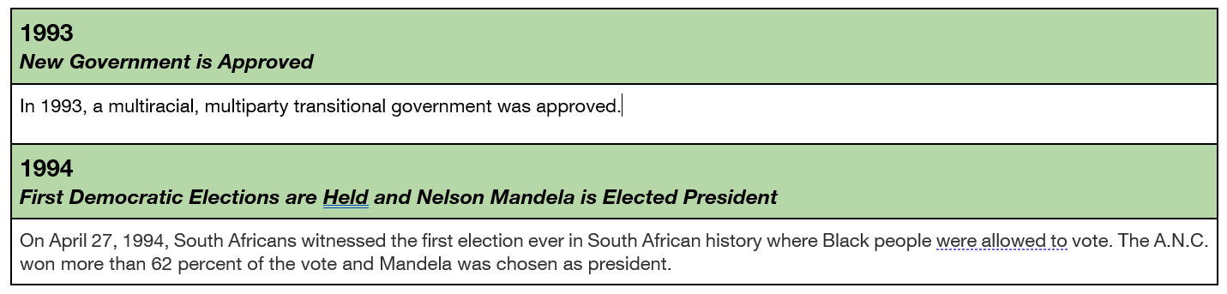

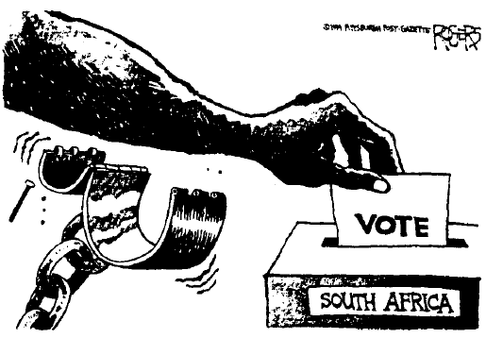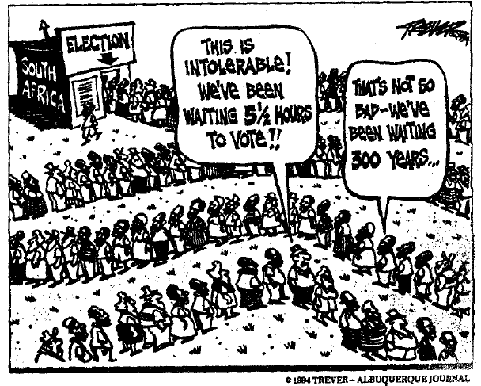

**18. What is the message of each political cartoon?**